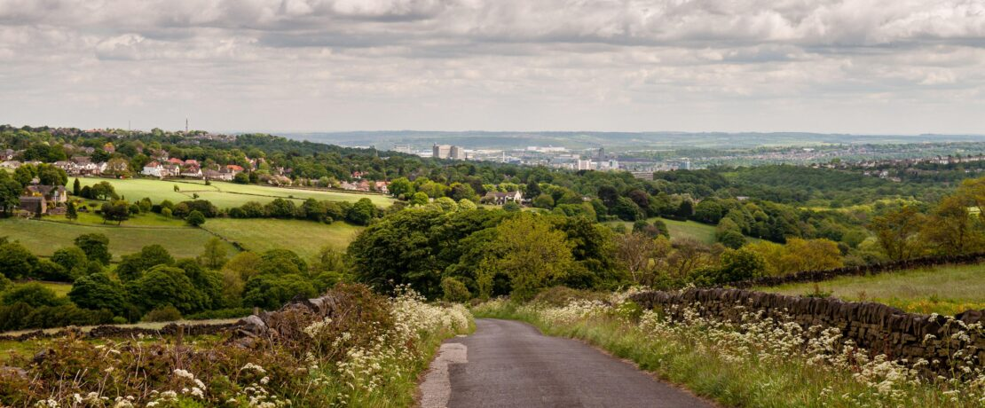
Joe Dunckley / Alamy
11th May 2026

The Campaign to Protect Rural England (CPRE) has launched its ‘On the Edge’ campaign, which will be showcased in the garden of the same name at the RHS Chelsea Flower Show 2026.
Together, they celebrate fragile, often-forgotten countryside on the edges of England’s towns and cities – and call for urgent government action to protect it.
Add your name
The campaign invites people across England to pledge their support and contribute to what CPRE believes will be the first-ever interactive map of the English countryside on the edges of towns and cities. The map is powered by people’s own stories and memories of the places that matter to them.
The ‘On the Edge’ garden has been designed by Sarah Eberle, the most decorated British garden designer at Chelsea, in her 20th year at Chelsea and 50th in horticulture.
The ‘edgelands’ around our towns and cities are among the most undervalued landscapes in the country. Under constant threat of development and neglected by policymakers, they are simultaneously vital corridors for nature, critical buffers against climate change and the primary point of contact with the countryside for the 85% of Britons who live in urban areas.

Edgelands ‘central’ to restoring land
Most people do not realise that England has only 14 Green Belts, which protect land around our biggest cities from development. No new Green Belts have been created since the policy was established in the 1950s. At a time when the government has committed to restoring 30% of the UK’s land for nature by 2030 (the figure is just 7% today), CPRE believes edgelands must be central to the national response.
The ‘On the Edge’ campaign calls on government to:
- Protect England’s Green Belts by reversing the most damaging impacts of grey belt policy to explicitly exclude Local Nature Reserves and the best agricultural land.
- Value our edgelands by setting brownfield-first housebuilding targets, creating a new generation of country parks and establishing five new Regional Parks in areas with limited countryside access.
- Support edgeland farmers by providing bespoke support for smallholdings and market gardens – and preventing the further sale of county farms.
- Involve communities by backing Community Land Trusts, Local Green Space designations, and committing to the promise that everyone lives within a 15-minute walk of green or blue space.
Read our policy asks in full

‘Resilience’ in unlikely places
The ‘On the Edge’ show garden directly embodies the campaign message in horticultural form. At its heart is a striking land art sculpture: a fallen tree carved into a guardian figure – Gaia or Mother Nature – still supporting life, with willow hair woven into a dry-stone wall. It is a monument to the resilience of nature in unlikely places.
Native planting throughout the garden celebrates species often dismissed as weeds – meadow buttercups, dog violets – while the overall aesthetic channels the spirit of ‘guerrilla gardening’: plants reclaiming neglected ground from fly-tipped garden waste, transforming abandonment into abundance.
From Chelsea, the garden will be relocated to a regenerated housing development in urban Sheffield, continuing the legacy of Ethel Haythornthwaite, one of CPRE’s earliest campaigners and a driving force behind the creation of the Sheffield Green Belt. The relocation ensures the garden’s message lives on in the very kind of urban edge landscape championed by the new campaign.

Giving edgelands the ‘recognition and protection they deserve’
Roger Mortlock, chief executive of CPRE, said:
‘England’s edgelands are hiding in plain sight – for too long we’ve taken them for granted. These are the places where many of us first fell in love with the natural world: the scrubby fields at the end of the bus route, the overgrown towpaths, the orchards clinging on between the ring road and the retail park.
‘Our edgelands provide us with food and flood protection, they give wildlife space to thrive and allow tens of millions of people every day to enjoy the natural world – yet they remain among the least protected and most under-pressure landscapes in the country.
‘As CPRE marks its centenary, we’re calling on the government to finally give edgelands the recognition and protection they deserve – and on people everywhere to share their own edgeland stories and help us build a picture of what’s at stake.’
Sarah Eberle, garden designer, said:
‘It’s been a joy to create a garden that feels both restorative and deeply connected to nature, while highlighting the importance of the threatened landscapes on the edges of our towns and cities. Working with such skilled artisans has helped bring that message to life in a natural and very honest way.’
Hattie Ghaui, CEO of Project Giving Back, said:
‘PGB is really proud to have tempted Sarah back to RHS Chelsea with a cause that is close to her heart. As a true grande dame of UK horticulture it feels poignant that Sarah has chosen Gaia – Mother Nature – as the garden’s focal point. From its inception, PGB has been committed to encouraging new talent to RHS Chelsea, encouraged and supported by designers working at the top of their game. Sarah is certainly doing that this year, enabling the next generation of designers and horticulturists to feel supported to follow in her, and others’ footsteps.’
Read more about the campaign

