Enclosure
Fig 1
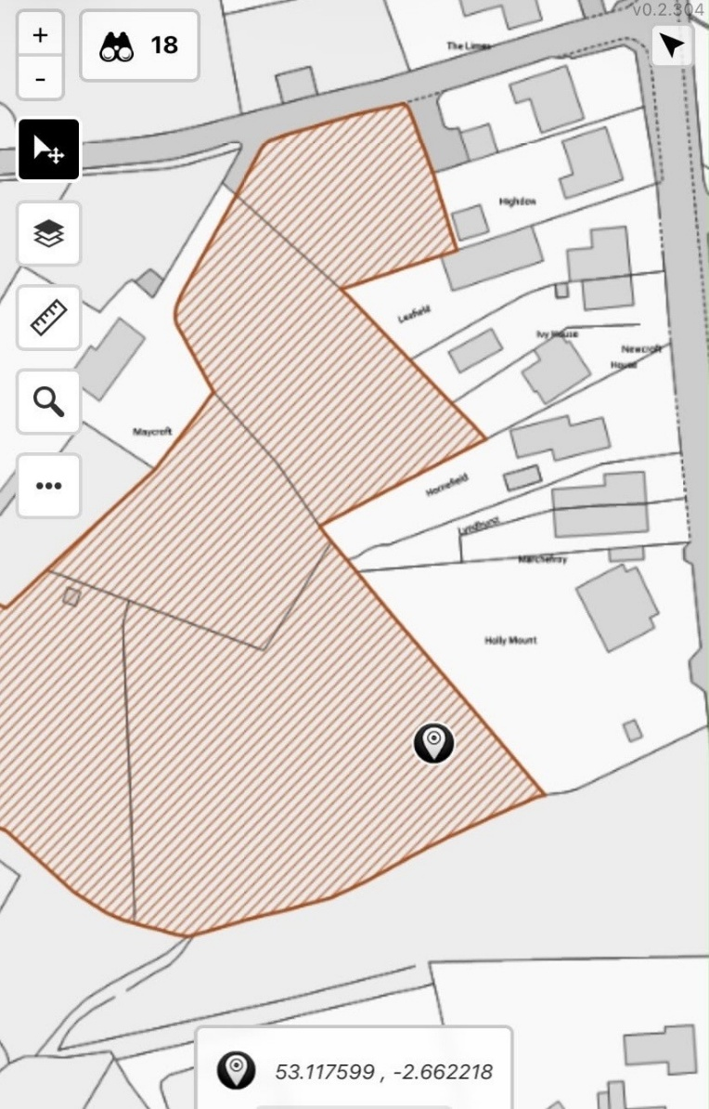

- Photographs of wildflower hay meadow on site (May 2026)

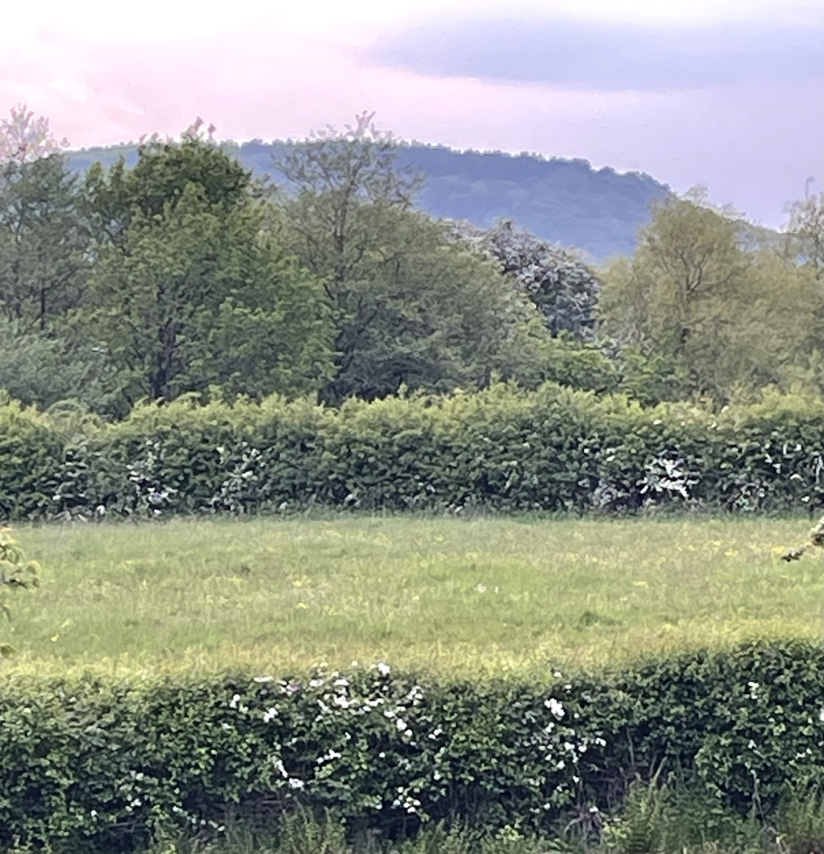

- Photographs of wildflower hay meadow on site (May 2023)

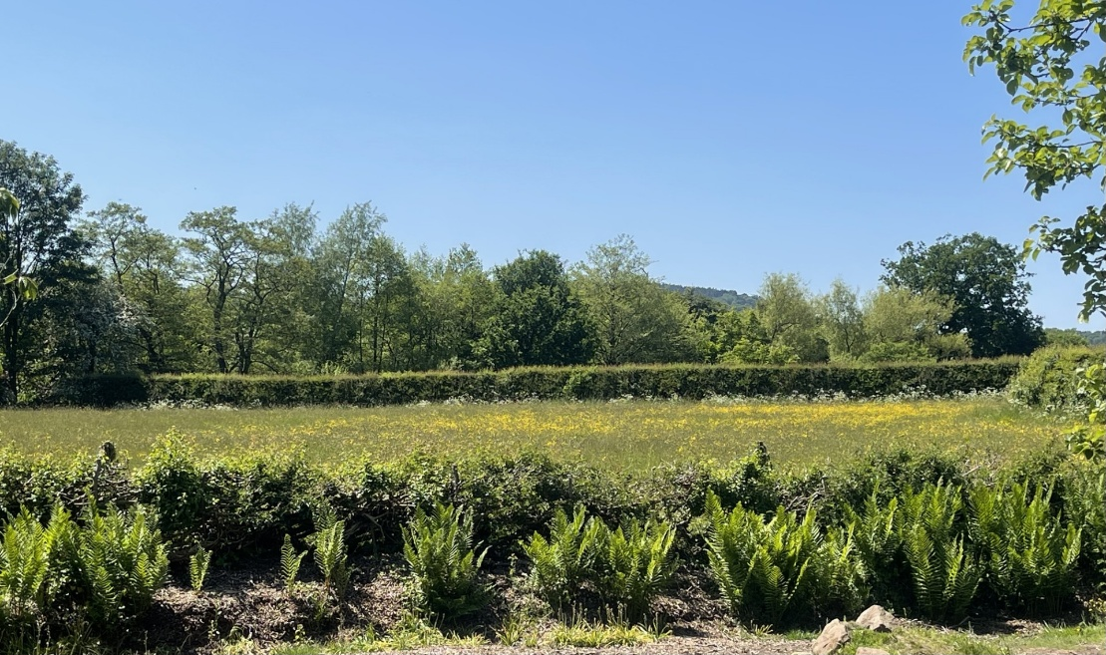
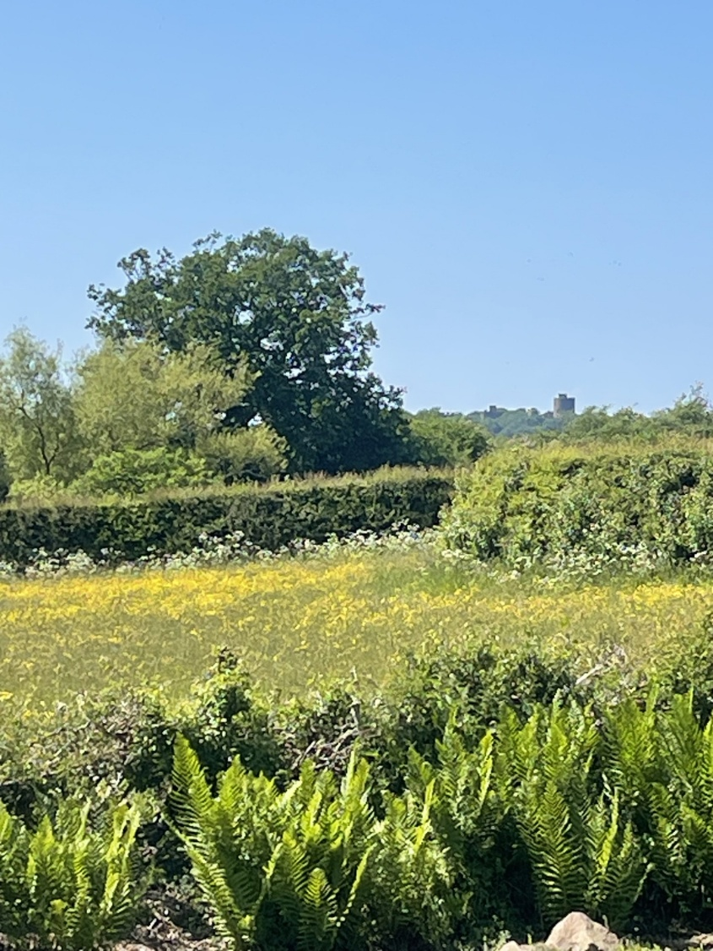

- Photographs of open view to Peckforton Castle, taken from Holly Mount (August 2026 and June 2023)

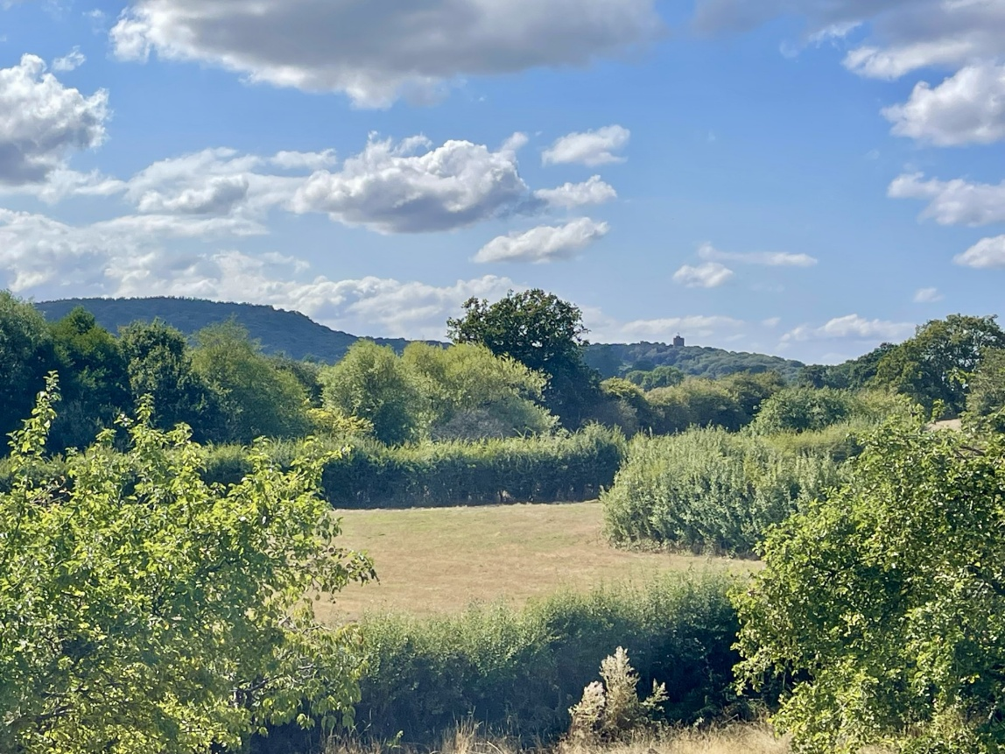
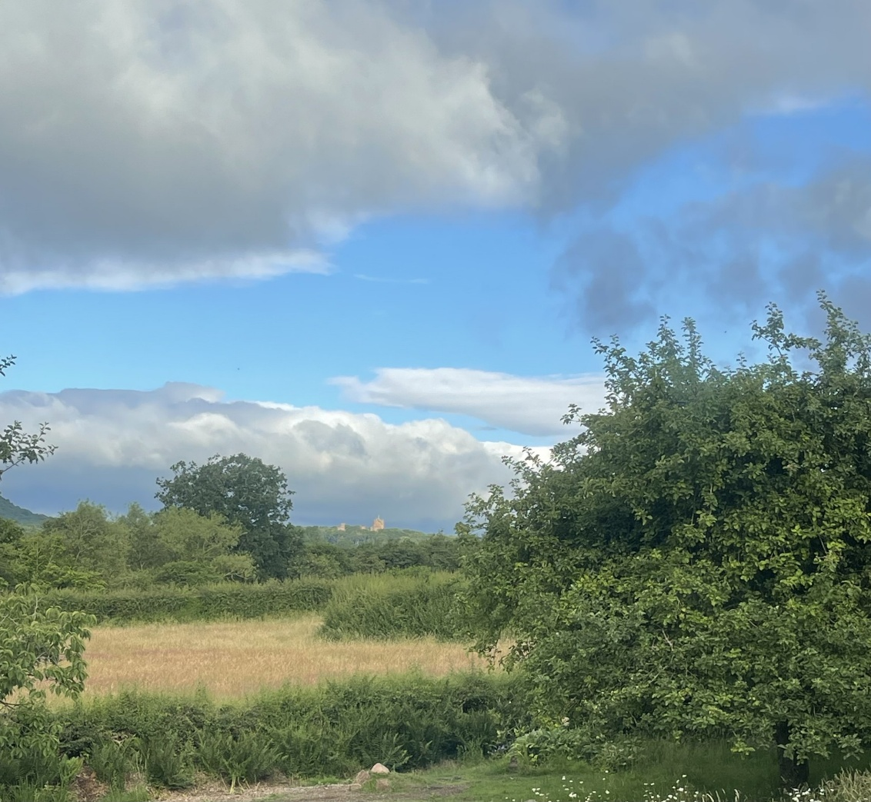
- RoadRisk collision map (roadrisk.co.uk) extract showing recorded collisions on the A49 (Whitchurch Road) in this location
