FORMAL REPRESENTATION – CHESHIRE EAST NEW LOCAL PLAN
Objection to Potential Allocation of Tatton Estate Land at Ashley
To: Strategic Planning Team, Cheshire East Council
Dear Strategic Planning Team,
Please accept this as my formal representation concerning the potential allocation for substantial development of land promoted by the Tatton Estate at Ashley.
I strongly object to the allocation of this land for substantial residential development.
I live on Ashley Road, immediately adjacent to the railway line and close to Ashley railway station, with open agricultural land directly behind my property.
My objection is not simply about the loss of a private view. It concerns the fundamental suitability and sustainability of substantial development in this location, including documented historic flooding and surface-water drainage; wildlife and ecology; the limited capacity and physical constraints of Ashley railway station; the absence of everyday services and mainstream schooling within the village; the constrained rural road network; Green Belt and landscape impacts; Ashley's rural and nighttime character; infrastructure capacity; the scale of development relative to the existing village; and the cumulative implications of possible longer-term expansion.
I also ask the Council to consider previous formal representations made by the Tatton Estate itself concerning many of these same constraints.
1. DOCUMENTED HISTORY OF FLOODING – PARTICULARLY PARCEL 6
The surrounding agricultural land naturally falls towards a low point where substantial standing water can accumulate during prolonged or heavy rainfall. This is not a theoretical future concern.
The particular area of land referred to in this representation, where the significant and recurring flooding described below occurs, is Parcel 6.
I hold a photograph dated 2 May 2016 showing extensive standing floodwater across the low-lying agricultural field. I also hold photographic evidence dated 19 July 2019 showing significant flooding immediately outside my property on Ashley Road, with standing water reaching the house. My property has experienced flooding on more than one occasion.
These photographs demonstrate that the agricultural land itself experiences substantial surface-water flooding and that an existing neighbouring residential property has also experienced flooding.
During the wetter months, and particularly following periods of heavy rainfall, I have personally observed the level and extent of standing water across the lower fields become substantially greater than may be apparent during dry conditions.
On occasions, the floodwater has risen so extensively that the field fencing separating the agricultural fields is no longer visible above the water. This condition can persist for prolonged periods during wet months and demonstrates the severity and seasonal nature of the existing surface-water problem.
The attached photographic evidence should therefore be considered alongside my direct observations of more severe flooding at other times of the year. A site inspection undertaken during dry weather would not necessarily provide a representative picture of the drainage and flood conditions experienced during prolonged rainfall.
I have also personally witnessed severe surface-water flows during periods of intense rainfall. During flash-flood conditions, I have observed large volumes of water flowing down the hill from the direction of Ashley Station bridge towards the Greyhound public house, with the flow appearing like a river along this part of Ashley Road.
In my experience, this creates a serious flooding risk to properties on the right-hand side of Ashley Road when travelling downhill, extending towards the commercial premises adjacent to Warford Cars, where I have also witnessed flooding.
These observations are particularly relevant to Parcel 6 because they demonstrate that the flooding issue is not simply isolated standing water within one field. There appears to be a wider surface-water flow pathway through this low-lying part of Ashley during periods of intense rainfall.
In view of the extent and persistence of this existing flooding, I have serious concerns about whether a drainage strategy for substantial residential development could safely accommodate the volume of surface water without increasing flood risk within the proposed development or displacing water towards existing properties and surrounding land.
I therefore request that Parcel 6 is not assessed in isolation and that any flood-risk and drainage assessment considers the existing catchment, topography, overland flow routes and potential consequences for existing properties both upstream and downstream.
I request that the Council does not rely solely upon mapped river Flood Zones when assessing this land. Any assessment should examine:
- the actual topography of the entire proposed development area;
- historic surface-water flooding and natural surface-water flow paths;
- the location and function of existing low-lying areas and existing drainage capacity;
- the consequences of altering ground levels;
- the effect of houses, roads, driveways and other impermeable surfaces;
- climate-change allowances and extreme rainfall events;
- the potential displacement or concentration of water towards existing properties; and
- the cumulative drainage consequences of developing adjoining parcels.
I therefore request that, before the land is considered suitable for allocation, Cheshire East Council requires a comprehensive and independent hydrological and surface-water drainage assessment based on the site's actual topography, historic flooding and severe wet-weather conditions.
Any proposed drainage solution should demonstrate, with appropriate allowances for climate change and extreme rainfall, that development would not increase flood risk either on the proposed site or elsewhere.
Given the documented history of flooding, flood risk and drainage should be treated as a fundamental consideration when determining whether this land is suitable for allocation, rather than simply being deferred to detailed drainage design at a future planning-application stage.
2. WILDLIFE, RAILWAY EMBANKMENT AND SEASONAL HABITAT
The proposed development should be considered in the context of the existing wildlife habitat immediately surrounding the site.
The railway embankment close to the proposed development contains long-established wild hedgerows, bramble and dense natural vegetation. This provides continuous cover and habitat alongside the railway and connects with surrounding fields, gardens, hedgerows and open countryside.
I have personally observed badgers and other wildlife using this area. I am not asserting the location of any particular badger sett. Given the presence of badgers and the extent of suitable cover, I request professional surveys for badger activity, including any setts, established routes and foraging areas that may be affected by development.
There is significant bat activity. I regularly observe bats flying and feeding around my garden and adjoining open land. Swifts also nest in the car barn at my property.
The low-lying agricultural fields provide additional seasonal habitat when waterlogged or flooded. Over many years I have personally observed swans, ducks, geese and numerous other birds using these areas, and I hold photographic evidence showing a swan using standing water within the field.
Taken together, the railway embankment, established hedgerows and bramble, adjoining gardens, agricultural fields and seasonally flooded areas potentially form a connected network of habitat rather than isolated individual features.
I request appropriately timed ecological surveys covering badgers; bats and their commuting and foraging routes; breeding and wintering birds; the railway embankment; hedgerows, bramble, field margins and mature trees; seasonally wet and flooded areas; habitat connectivity and wildlife corridors; and other protected species identified as potentially present by a suitably qualified ecologist.
The assessment should consider habitat loss and fragmentation, construction activity, increased human activity, domestic pets, traffic, noise and artificial lighting. These ecological assessments should be appropriately timed and undertaken before the land is considered suitable for allocation.
3. ASHLEY RAILWAY STATION AND GENUINE TRANSPORT SUSTAINABILITY
The presence of Ashley railway station appears to form an important part of the argument that substantial development at Ashley could constitute sustainable development. However, the actual capacity and physical limitations of the station must be considered.
Ashley has a very short platform. When travelling to Ashley, passengers cannot simply alight from every carriage. In my experience, passengers are required to position themselves in the appropriate part of the train because only the first two carriages can be used for passengers alighting at Ashley due to the limited platform length.
This is a significant practical constraint at the very station being relied upon to support the sustainability credentials of substantial development.
I request that the Council establishes with the relevant railway authorities existing passenger numbers and spare capacity; current and realistic future service frequency; platform length and passenger capacity; whether longer or more frequent trains could practically be accommodated; whether platform extensions would be required; accessibility, pedestrian access, parking and drop-off implications; the capacity of surrounding railway infrastructure; and the cost, funding and deliverability of improvements necessary to support substantial population growth.
The mere existence of a railway station should not establish that a location is sustainable for large-scale development. Its actual service, capacity and infrastructure must be capable of supporting the population proposed.
4. LACK OF EVERYDAY SERVICES AND COMMUNITY INFRASTRUCTURE
The existing level of services within Ashley should be accurately considered when assessing whether the village represents a genuinely sustainable location for substantial residential growth.
Ashley previously had a village store. That premises no longer operates as a village shop and is now occupied by a specialist private business. There are a small number of other commercial premises within the village, including a car sales business and a fabric-printing business. These provide economic activity but not the everyday retail or community services required by a substantially increased residential population.
Ashley therefore presently has no village convenience store or meaningful everyday retail provision. There is also no mainstream primary or secondary school within the village. A small former school premises is presently used for specialist educational provision; this should not be treated as mainstream school capacity for children generated by substantial new residential development. Ashley also has no GP surgery or pharmacy within the village.
Consequently, residents need to travel outside Ashley for many basic requirements, including mainstream schooling, substantial grocery shopping, healthcare and numerous other everyday services.
The Council should establish where children generated by the development would attend mainstream primary and secondary schools and the capacity of those schools; how pupils would travel to school; where residents would obtain everyday groceries and access GP and pharmacy services; the additional vehicle journeys resulting from the absence of these facilities; what new schools, shops, healthcare and community facilities would actually be provided; whether those facilities are viable and adequately funded; and when those facilities would become operational.
If new facilities are relied upon to establish sustainability, their delivery, funding, capacity and timing should be demonstrated and secured, rather than relying upon facilities shown only indicatively on a masterplan.
5. ASHLEY'S CONSTRAINED RURAL ROAD NETWORK
Ashley Road and the surrounding highway network retain the physical characteristics of rural roads. Substantial residential development would inevitably generate additional vehicle movements, including journeys that could not realistically be transferred to rail.
The Council should assess cumulative traffic impact upon Ashley Road, Mobberley Road, Back Lane and the surrounding road network, including railway bridges and constraints affecting pedestrians and cyclists.
Of particular relevance is evidence previously submitted by the Tatton Estate itself. In formal representations concerning HS2, Tatton Estate objected to construction traffic using local unclassified roads and described such roads as "unsuitable for use by HGVs." The roads identified included Ashley Road, Mobberley Road, Back Lane, Tanyard Lane and Castle Mill Lane.
I recognise that construction HGV traffic and ordinary residential traffic are not identical. However, these previous representations demonstrate that the Estate itself has recognised significant physical limitations within Ashley's rural highway network.
I therefore request robust independent modelling of the cumulative traffic associated with substantial residential development before this land is considered suitable for allocation.
6. TATTON ESTATE'S PREVIOUS RECOGNITION OF ASHLEY'S RURAL SETTING
Tatton Estate's previous formal representations concerning HS2 are also relevant to landscape character. When objecting to infrastructure proposed around Ashley, the Estate expressed concern about a "lasting impact on the rural setting of Ashley."
The Estate also raised concerns about significant landscape and visual effects, noise and environmental impacts upon sensitive receptors.
These statements are relevant because the fundamental characteristics previously identified by the Estate – Ashley's rural setting, landscape sensitivity and existing residents – remain present today.
Substantial residential development would introduce permanent buildings, roads, traffic, domestic lighting, street lighting and associated infrastructure into that same rural environment. I request that Cheshire East applies equally rigorous scrutiny to the landscape and visual consequences of the present proposals.
7. GREEN BELT AND ASHLEY'S RURAL CHARACTER
The open agricultural countryside surrounding Ashley is fundamental to the identity and setting of the village. My property currently lies at the interface between the existing settlement and open countryside.
Development of the fields immediately adjoining existing Ashley Road properties would fundamentally alter that relationship.
This is not simply about residents losing private views. It concerns the urbanisation of an established rural settlement edge and the permanent alteration of the landscape character and setting of Ashley.
The Council should rigorously assess the Green Belt function of this land, its contribution to openness and Ashley's rural setting, landscape and visual effects, cumulative effects across adjoining parcels, and whether development requirements could be accommodated in less environmentally sensitive locations.
8. ASHLEY'S DARK RURAL NIGHTTIME ENVIRONMENT
Ashley presently retains a strongly rural nighttime character, with comparatively little artificial illumination across the surrounding agricultural fields.
Substantial development would introduce street lighting, domestic lighting, vehicle headlights and other sources of artificial illumination into presently dark countryside.
This has implications for both landscape character and ecology, particularly given the regular bat activity I personally observe.
I request a baseline nighttime lighting assessment and consideration of effects upon bats and their feeding and commuting routes, other nocturnal wildlife, existing residents and the rural nighttime character of Ashley.
9. HYDROLOGY – APPLYING A CONSISTENT EVIDENTIAL STANDARD
Tatton Estate has previously emphasised the importance of understanding hydrological conditions where major infrastructure could affect its land and environmental interests.
I respectfully submit that an equivalent evidential standard should apply where land is now being promoted by the Estate itself for substantial residential development.
This is particularly important because I can provide dated photographic evidence of actual historic surface-water flooding affecting both the agricultural land and an existing neighbouring property.
Independent hydrological and drainage evidence should therefore be available before the Council determines that this land is suitable for allocation.
10. ECOLOGY – APPLYING A CONSISTENT EVIDENTIAL STANDARD
In previous representations concerning HS2, Tatton Estate raised concerns regarding the adequacy of information concerning protected species, including bats and wintering and breeding birds.
Those are precisely the types of ecological interests requiring investigation here.
I regularly observe bats around my property and adjoining open land, swifts nest at my property, badgers use the vegetated railway embankment area, and swans, ducks, geese and other birds use the seasonally flooded fields.
I request that the same rigorous approach to ecological evidence previously sought by the Estate is applied to its current development proposals.
11. SCALE OF DEVELOPMENT RELATIVE TO ASHLEY
Ashley is a small rural settlement. The scale of development being contemplated could represent a profound increase in its physical size and population.
The Council should consider whether such development genuinely constitutes proportionate growth of Ashley or whether, in practical terms, it would create a substantial new settlement around an existing small village.
This assessment should be based upon infrastructure as it actually exists today and upon improvements that are demonstrably realistic, funded and deliverable.
12. CUMULATIVE AND LONGER-TERM EXPANSION
Tatton Estate's material also identifies additional surrounding areas as having potential for significantly longer-term development. Even if these areas do not form part of the present proposal, their identification makes cumulative assessment particularly important.
The Council should consider whether allocating substantial development at Ashley now could establish a development foothold facilitating further expansion into surrounding countryside during subsequent Local Plan periods.
Flooding, drainage, ecology, landscape, highways, infrastructure and settlement character should therefore be considered cumulatively rather than parcel by parcel.
13. TATTON ESTATE'S PREVIOUS REPRESENTATIONS – OVERALL RELEVANCE
I recognise that HS2 construction and residential development are not identical.
I refer to Tatton Estate's previous representations because they provide evidence that the Estate itself has previously recognised constraints affecting Ashley's rural road network; the importance of Ashley's rural setting; landscape and visual sensitivity; potential noise and environmental impacts; the importance of hydrological investigation; and the requirement for adequate ecological evidence.
These characteristics do not cease to be relevant because the Estate is now promoting development rather than responding to development proposed by another party.
I respectfully request that Cheshire East Council requires the current proposal to demonstrate, through independent, comprehensive and transparent evidence, how these recognised constraints can satisfactorily be addressed before any of this land is considered suitable for allocation.
CONCLUSION
For all the reasons set out above, I object to the potential allocation of the Tatton Estate land at Ashley for substantial residential development.
I request that Cheshire East Council gives particular consideration to the documented and recurring flooding of Parcel 6; the substantial seasonal water levels; the observed flash-flood and overland water flows along Ashley Road; historic flooding affecting both the field and my property; surface-water drainage and topography; flood risk to existing homes and any future development; seasonal wildlife and ecology; badgers, bats, nesting birds and waterfowl; Ashley station's actual infrastructure and capacity; the absence of mainstream schools and everyday services; the constrained rural highway network; Green Belt openness; Ashley's landscape and rural setting; its dark nighttime environment; infrastructure capacity; the scale of development relative to the existing village; and the cumulative implications of potential longer-term expansion.
These are site-specific and evidenced concerns based upon my direct experience of living immediately adjacent to the land in question.
I respectfully request that this representation and accompanying photographic evidence are formally recorded and considered throughout the Local Plan site-assessment process.
I would also ask to be notified of future consultation stages concerning the Tatton Estate land at Ashley.
Yours faithfully,
Christopher Baguley
Charlotte Baguley
[Redacted]
SUPPORTING PHOTOGRAPHIC EVIDENCE
Appendix A – 2 May 2016
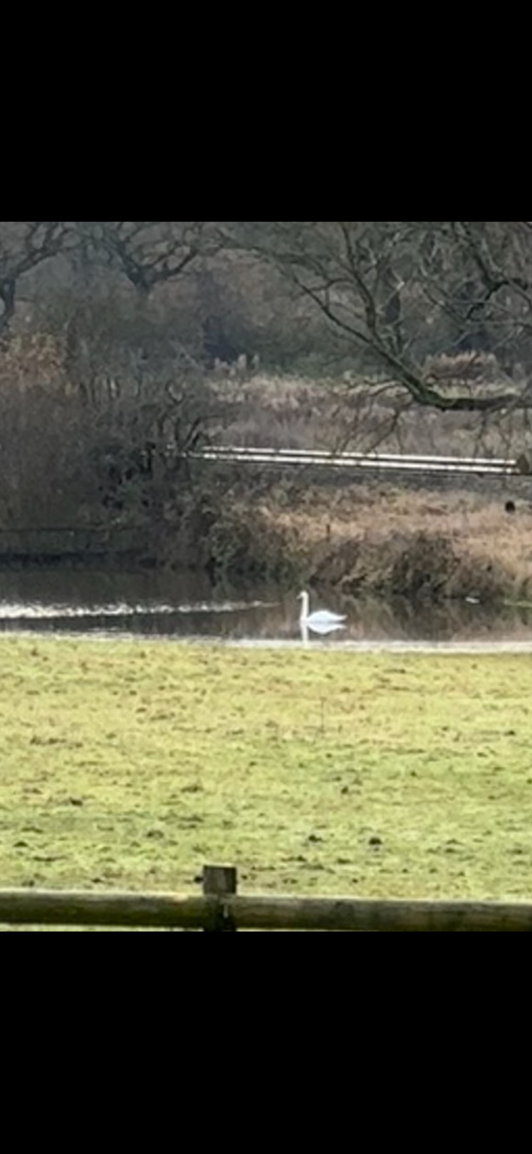
Substantial standing floodwater across the low-lying agricultural field. This photograph is submitted as evidence of historic surface-water accumulation on the land.
Appendix B – 19 July 2019
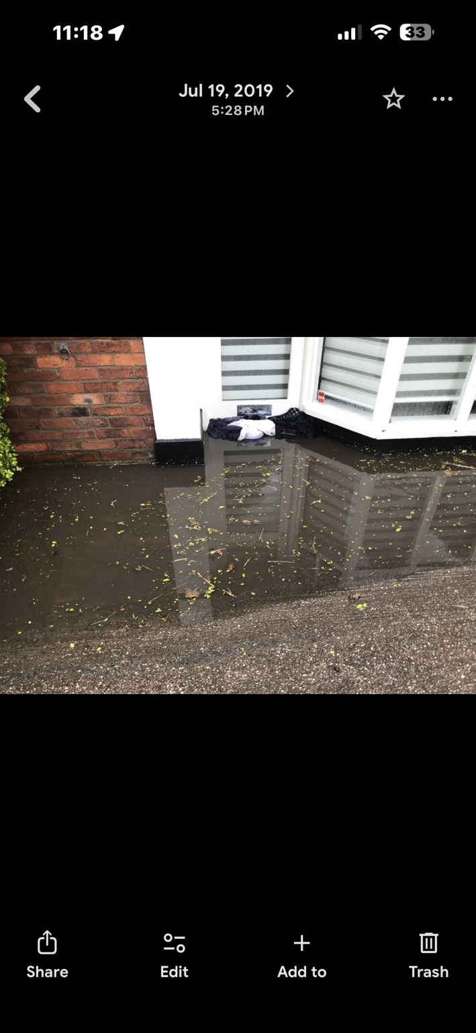
Significant standing floodwater immediately outside the Ashley Road property, with water reaching the house.
Appendix C – Seasonal wildlife
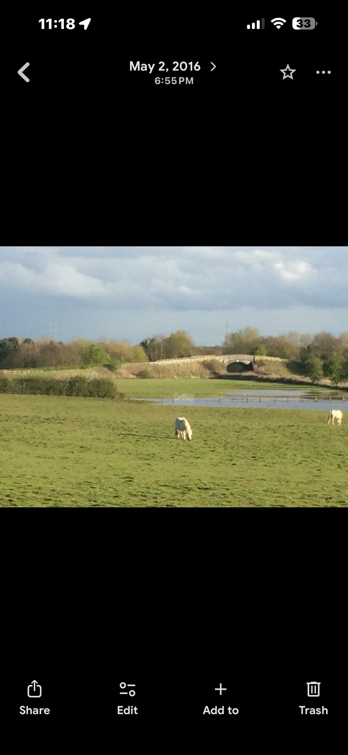
A swan using standing water within the low-lying field, illustrating wildlife use of the seasonally flooded land.

